CS550 Project #6  
Xiaoru Chen  
Email: chenxia2@oregonstate.edu

**A Screen shot from my program:**

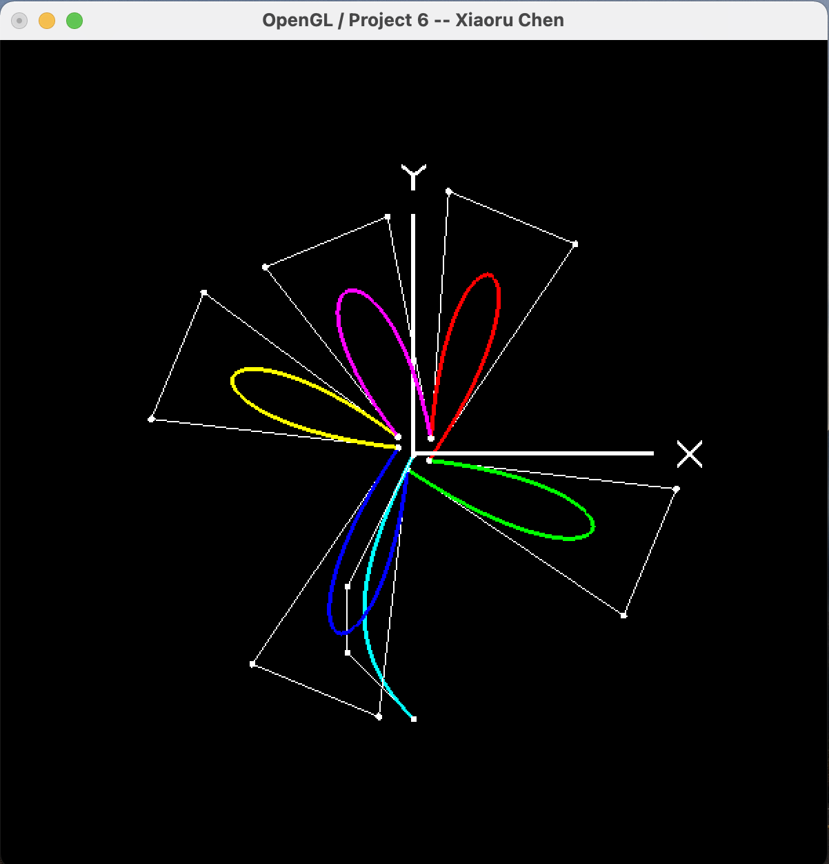

**What I did:**

In this project 6, I drew a flower with five petals, and each petal is animated. There is 1 stationary 3D curve, that is the stem.

Turn on and off the control points by pressing “K” or “k”.

Turn on and off the control lines by pressing “L” or “l”.

All the curves are 3D, their Z values are not constant.

Curves for the five petals are moving back and forth along with axis Z.

**The link to the Kaltura video:**

<https://media.oregonstate.edu/media/t/1_8rliwvzq>